TRANSFORMERS ALGORITHM
Traditional Neural Networks → RNN → LSTM/GRU → Attention → Transformer → BERT/GPT → Modern LLMs
I'll explain it from zero to advanced level, using simple language, equations only where they actually help, and practical examples.
🚀 Complete Transformer Mastery Roadmap
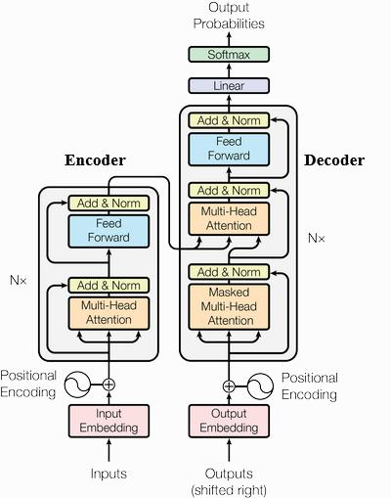
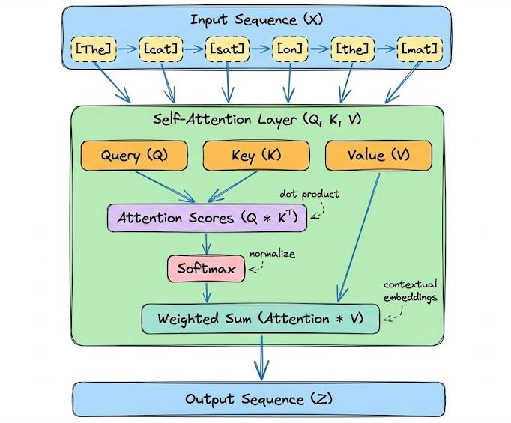
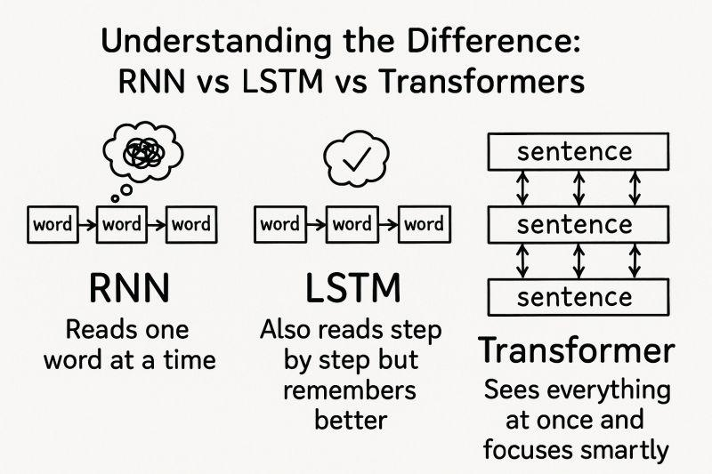
4
What you will learn
Level 1 — Foundations
- What is Deep Learning?
- Neural Networks
- Sequential data
- Why ordinary neural networks struggle with sequences
- RNN
- Problems with RNN
- LSTM
- GRU
- RNN vs LSTM vs GRU
Level 2 — Attention
- What is Attention?
- Why Attention was needed
- Query, Key, Value
- Attention Score
- Softmax
- Attention weights
- Context vector
- Self-Attention
- Multi-Head Attention
Level 3 — Transformer
- What is Transformer?
- Original Transformer architecture
- Encoder
- Decoder
- Input Embeddings
- Positional Encoding
- Self-Attention
- Multi-Head Attention
- Feed Forward Network
- Residual Connections
- Layer Normalization
- Masking
- Cross-Attention
- Output probabilities
Level 4 — Transformer Variants
- Encoder-only models
- Decoder-only models
- Encoder-decoder models
- BERT
- GPT
- T5
- RoBERTa
- ALBERT
- DistilBERT
Level 5 — Generative AI
- GPT architecture
- Autoregressive generation
- Next-token prediction
- Tokenization
- Vocabulary
- Temperature
- Top-k
- Top-p
- Sampling
- Context window
- KV Cache
Level 6 — Advanced Transformers
- Causal Attention
- Cross Attention
- Rotary Positional Embeddings
- ALiBi
- Flash Attention
- Grouped Query Attention
- Multi-Query Attention
- Mixture of Experts
- Long-context Transformers
- Vision Transformers
- Multimodal Transformers
Level 7 — Training
- Pretraining
- Fine-tuning
- Instruction tuning
- RLHF
- DPO
- Transfer learning
- LoRA
- QLoRA
- Quantization
Level 8 — Implementation
- Implement RNN
- Implement LSTM
- Implement Attention
- Implement Self-Attention
- Implement Transformer from scratch
- Implement GPT from scratch
- Use PyTorch
- Fine-tune Hugging Face models

PART 1 — Why Do We Need Transformers?
Let's start with the problem.
Suppose we have this sentence:
"I went to the bank to deposit money."
A model needs to understand that bank probably means a financial institution.
Now consider:
"I sat beside the bank of the river."
Here bank means something different.
The model needs to understand the relationship between words.
This is called context.

1. What is Sequential Data?
Sequential data is data where order matters.
Examples:
I love Python
Changing the order:
Python love I
changes the meaning.
Examples of sequential data:
- Text
- Speech
- Time series
- Stock prices
- Sensor data
- DNA sequences
- Music
Traditional neural networks aren't naturally designed to remember relationships across a sequence.
That's where RNNs came in.

2. RNN — Recurrent Neural Network
RNN stands for:
Recurrent Neural Network
The key idea is:
RNN processes sequence one element at a time and carries information from previous steps.
Consider:
I → love → Python
RNN processes:
I
↓
love
↓
Python
At every step, RNN maintains a hidden state.
Simplified:
Input
↓
RNN
↓
Hidden State
↓
Next RNN
↓
Next Hidden State
Mathematically:
Don't worry about memorizing this yet.
The important idea is:
Current input
+
Previous memory
↓
New memory

3. Example of RNN
Sentence:
I love machine learning
RNN processes:
Step 1
I
↓
RNN
↓
h1
Step 2
love + h1
↓
RNN
↓
h2
Step 3
machine + h2
↓
RNN
↓
h3
Step 4
learning + h3
↓
RNN
↓
h4
The hidden state carries information forward.

4. The Big Problem With RNN
Suppose:
"The boy who was playing football near the school with his friends yesterday was happy."
The word:
was
needs to relate to:
boy
But there are many words between them.
As sequences become longer, ordinary RNNs struggle to preserve old information.
This leads to:
Vanishing Gradient Problem

A gradient is simply a signal that tells a neural network how much and in which direction its weights should change to reduce the error. During training, this signal travels backward through the network using backpropagation. In a vanishing gradient, this signal becomes smaller and smaller as it travels backward through many layers or time steps, eventually becoming almost zero. Because the signal is so small, the earlier layers or earlier steps barely update their weights and learn very slowly. In simple words, vanishing gradient means the learning signal gets weaker and weaker as it goes backward, so the beginning of the network doesn't learn properly.
During training, gradients can become extremely small.
Consequently:
Early information
↓
gets weaker
↓
gets weaker
↓
gets weaker
Eventually the network may effectively forget earlier information.
There is also an exploding gradient problem, where gradients become extremely large.

5. LSTM
LSTM stands for:
Long Short-Term Memory
LSTM was designed to improve RNN's ability to remember information for longer periods.
Instead of having only a hidden state, LSTM has:
Hidden State
+
Cell State
The cell state acts somewhat like a long-term memory highway.

6. LSTM Gates
This is one of the most important concepts.
LSTM uses three major gates:
1. Forget Gate
Decides:
What information should I forget?
2. Input Gate
Decides:
What new information should I remember?
3. Output Gate
Decides:
What information should I output?
Simplified:
┌──────────────┐
Previous ────→│ Forget Gate │
└──────────────┘
↓
┌──────────────┐
Current ─────→│ Input Gate │
└──────────────┘
↓
┌──────────────┐
│ Cell State │
└──────────────┘
↓
┌──────────────┐
│ Output Gate │
└──────────────┘
↓
Hidden State
This makes LSTM much better at handling long-term dependencies than vanilla RNN.

7. GRU
GRU stands for:
Gated Recurrent Unit
It is another improvement over RNN.
GRU is generally simpler than LSTM.
LSTM:
Cell State
+
Hidden State
+
3 gates
GRU:
Hidden State
+
fewer gates
So GRU often has fewer parameters and can be faster.

8. RNN vs LSTM vs GRU
Feature | RNN | LSTM | GRU
Memory | Short | Long | Long
Gates | No | 3 | 2
Cell state | No | Yes | No
Long dependencies | Poor | Good | Good
Training | Sequential | Sequential | Sequential
Parallelization | Poor | Poor | Poor
Complexity | Low | High | Medium
But even LSTM has a fundamental problem:
It processes tokens sequentially.
That brings us to Attention.

PART 2 — ATTENTION
9. Why Attention?
Suppose:
"The cat that was sitting on the table was hungry."
When processing:
hungry
the model should pay strong attention to:
cat
instead of:
the
that
was
sitting
on
the
table
Attention allows the model to ask:
Which other words are important for understanding this word?
That's the key breakthrough.

10. Attention — Simple Example
Sentence:
The cat sat on the mat
When processing:
cat
attention might look approximately like:
The 0.05
cat 0.40
sat 0.10
on 0.05
the 0.10
mat 0.30
The exact values aren't important here.
The important concept is:
The model assigns different importance to different words.

11. Query, Key, Value
This is extremely important for Transformers.
Think about a search engine.
You have:
Query
What am I looking for?
Key
What information do I contain?
Value
What actual information should I return?

In Transformer attention:
Query
Key
Value
are generated from the input embeddings.

12. Attention Formula
The famous formula is:
Don't panic.
Break it into four steps.
Step 1
Calculate:
This measures similarity between queries and keys.
Step 2
Scale:
Step 3
Apply:
Softmax
This converts scores into probabilities/weights.
Step 4
Multiply by:
V
This creates the attention output.
So:
Q + K
↓
Similarity scores
↓
Scaling
↓
Softmax
↓
Attention weights
↓
× V
↓
Attention output

PART 3 — SELF-ATTENTION
13. What is Self-Attention?
This is the heart of Transformers.
In self-attention:
Every word looks at other words in the same sentence.
Example:
The dog chased the cat
The word:
chased
can look at:
The
dog
the
cat
and determine which words are important.

14. Self-Attention Example
Sentence:
The animal didn't cross the street because it was tired.
What does:
it
refer to?
Probably:
animal
Self-attention helps the model establish that relationship.
This is called a:
Long-range dependency
And this is where Transformers are extremely powerful.

15. How Self-Attention Works
Suppose we have:
I love Python
Each word gets an embedding.
I → embedding
love → embedding
Python → embedding
From each embedding we calculate:
Q
K
V
So:
Embedding
↓
┌───┬───┬───┐
↓ ↓ ↓
Q K V
Then:
Q × Kᵀ
gives attention scores.
Softmax converts those into weights.
Then:
Attention weights × V
produces contextualized representations.

PART 4 — TRANSFORMER
16. What is a Transformer?
The Transformer was introduced in the 2017 research paper:
"Attention Is All You Need"
The central idea was revolutionary:
Instead of relying on recurrence, use attention to model relationships between tokens.
The original architecture contained:
Encoder
+
Decoder

17. Transformer Architecture
Simplified:
INPUT
↓
Tokenization
↓
Embeddings
↓
Positional Encoding
↓
┌─────────────────────┐
│ ENCODER │
│ │
│ Self-Attention │
│ ↓ │
│ Add & Norm │
│ ↓ │
│ Feed Forward │
│ ↓ │
│ Add & Norm │
└─────────────────────┘
↓
ENCODER OUTPUT
↓
┌─────────────────────┐
│ DECODER │
│ │
│ Masked Attention │
│ ↓ │
│ Cross Attention │
│ ↓ │
│ Feed Forward │
│ ↓ │
│ Add & Norm │
└─────────────────────┘
↓
Linear Layer
↓
Softmax
↓
Next Token

18. Transformer Has Two Major Parts
Encoder
Understands the input.
Decoder
Generates output.
Think:
Encoder = Understand
Decoder = Generate

19. Encoder
An encoder layer contains:
Input
↓
Self-Attention
↓
Add & Norm
↓
Feed Forward Network
↓
Add & Norm
↓
Output
Multiple encoder layers can be stacked.
For example:
Encoder Layer 1
↓
Encoder Layer 2
↓
Encoder Layer 3
↓
...

20. Decoder
A decoder layer contains:
Input
↓
Masked Self-Attention
↓
Add & Norm
↓
Cross-Attention
↓
Add & Norm
↓
Feed Forward
↓
Add & Norm
Notice:
Decoder has masked self-attention.
Why?
Because during generation, the model shouldn't see future tokens.

PART 5 — TOKENIZATION
Before a Transformer processes text, text needs to become numbers.
For example:
I love Python
could become:
[45, 128, 932]
These are token IDs.
The process:
Text
↓
Tokenizer
↓
Tokens
↓
Token IDs
↓
Embeddings
↓
Transformer

21. What is a Token?
A token isn't necessarily a complete word.
For example:
unhappiness
could potentially become:
un
happi
ness
Different tokenizers use different strategies.
Common approaches include:
- BPE
- WordPiece
- SentencePiece
- Unigram

22. Embeddings
Token IDs themselves don't contain useful semantic information.
For example:
Python → 1827
The number 1827 doesn't inherently mean anything.
Instead, the model converts it into a vector:
Python
↓
[0.21, -0.73, 0.44, ...]
This is the embedding.

PART 6 — POSITIONAL ENCODING
Here's an important problem.
Attention processes tokens largely in parallel.
Consider:
Dog bites man
and:
Man bites dog
The words are the same.
But the meaning is completely different.
The model therefore needs information about:
Where is each token located?
That's the purpose of positional information.

23. Positional Encoding
Original Transformer used sinusoidal positional encoding.
Conceptually:
Token embedding
+
Position information
↓
Transformer input
For example:
I → position 1
love → position 2
Python → position 3
Modern Transformer architectures use several approaches, including:
- Sinusoidal positional encoding
- Learned positional embeddings
- RoPE
- ALiBi

PART 7 — MULTI-HEAD ATTENTION
24. What is Multi-Head Attention?
Instead of having only one attention mechanism, Transformer uses multiple attention heads.
Imagine reading:
"The dog chased the cat because it was angry."
One attention head might focus on:
pronouns
Another:
subject/object relationships
Another:
syntax
Another:
semantic relationships
This is a simplified intuition, not a guarantee that each head learns exactly one human-interpretable role.

25. Multi-Head Attention
Conceptually:
Input
↓
┌─────────┼─────────┐
↓ ↓ ↓
Head 1 Head 2 Head 3
↓ ↓ ↓
Attention Attention Attention
↓ ↓ ↓
└─────────┼─────────┘
↓
Concatenate
↓
Linear Layer
↓
Output
Formula:
where:

PART 8 — FEED-FORWARD NETWORK
After attention, the Transformer applies a small neural network to every token independently.
Usually:
Linear
↓
Activation
↓
Linear
Modern models often use activations such as:
- ReLU
- GELU
- SwiGLU
So:
Attention
↓
Feed Forward Network
↓
Better representation

PART 9 — RESIDUAL CONNECTIONS
This is another important concept.
Instead of:
x → Layer → output
we use:
x
↓
Layer
↓
+
↑
original x
Mathematically:
This is called a:
Residual connection / skip connection
It helps information and gradients flow through deep networks.

26. Layer Normalization
Transformers also use normalization.
Conceptually:
Neural network output
↓
Normalization
↓
Stable values
↓
Better training
This helps stabilize training.

PART 10 — MASKING
Masking is crucial for understanding GPT.
Suppose we want to predict:
I love machine learning
During training:
I → love
I love → machine
I love machine → learning
When predicting love, the model should not be allowed to look at:
machine
learning
So we use:
Causal mask
Example:
I love machine learning

I ✓ ✗ ✗ ✗
love ✓ ✓ ✗ ✗
machine ✓ ✓ ✓ ✗
learning✓ ✓ ✓ ✓
This is called:
Causal / autoregressive attention

PART 11 — CROSS-ATTENTION
Cross-attention appears in encoder-decoder architectures.
Example:
English → French translation
Encoder processes:
I love Python
Decoder generates:
J'aime Python
The decoder can attend to encoder representations.
So:
Decoder
↓
Query
↓
Encoder output → Keys + Values
This is different from self-attention.

27. Self-Attention vs Cross-Attention
Feature | Self-Attention | Cross-Attention
Q comes from | Same sequence | Decoder/current sequence
K comes from | Same sequence | Encoder output
V comes from | Same sequence | Encoder output
Purpose | Understand relationships within sequence | Connect output to input

PART 12 — BERT VS GPT
This distinction is extremely important for Generative AI interviews.
BERT
BERT is primarily:
Encoder-only
Architecture:
Input
↓
Encoder
↓
Contextual representation
BERT is excellent for understanding tasks such as:
- Classification
- Sentiment analysis
- Named entity recognition
- Question answering
- Semantic representation

28. GPT
GPT is primarily:
Decoder-only Transformer
Architecture:
Tokens
↓
Masked Self-Attention
↓
Feed Forward
↓
Masked Self-Attention
↓
Feed Forward
↓
...
↓
Next-token prediction
GPT is designed for generation.
For example:
Input:

The capital of France is

Model predicts:

Paris

29. Encoder vs Decoder vs Encoder-Decoder
Architecture | Example | Main Purpose
Encoder-only | BERT | Understanding
Decoder-only | GPT | Generation
Encoder-decoder | T5 | Input → output transformation
A simple way to remember:
BERT → Understand
GPT → Generate
T5 → Transform

PART 13 — HOW GPT GENERATES TEXT
Suppose the prompt is:
I love
GPT predicts probabilities:
Python 0.45
machine 0.20
coding 0.10
football 0.02
...
Suppose it chooses:
Python
Now:
I love Python
The model predicts the next token again.
Then:
I love Python because
Then:
I love Python because it
And so on.
This is:
Autoregressive generation

30. Next-Token Prediction
This is fundamental to GPT.
Training example:
Input:
The cat is

Target:
sleeping
The model learns:
For:
The cat is
it might predict:
sleeping → 0.65
hungry → 0.15
running → 0.08
...
Training minimizes the difference between the predicted distribution and the actual next token.
Usually this uses:
Cross-entropy loss

PART 14 — TEMPERATURE
Temperature controls randomness during generation.
Low temperature
0.1
More deterministic.
Higher temperature
1.0
More diverse.
Conceptually:
Low temperature
→ predictable

High temperature
→ creative/random

31. Top-K Sampling
Suppose:
Python 0.40
Java 0.20
SQL 0.15
C++ 0.10
football 0.01
...
With:
top_k = 3
we keep only:
Python
Java
SQL
and sample from those.

32. Top-P Sampling
Top-p uses cumulative probability.
For example:
Python 0.50
SQL 0.25
Java 0.15
C++ 0.05
...
If:
p = 0.90
we keep tokens until cumulative probability reaches approximately 0.90.
This is also called:
Nucleus sampling

PART 15 — RNN vs LSTM vs TRANSFORMER
This is one of the most important comparison tables to memorize.
Feature | RNN | LSTM | Transformer
Architecture | Recurrent | Recurrent + gates | Attention
Sequential processing | Yes | Yes | No recurrence
Parallel training | Poor | Poor | Excellent
Long dependencies | Poor | Good | Excellent
Memory mechanism | Hidden state | Cell + hidden state | Attention/context
Vanishing gradient | Major issue | Reduced | Much less central
Training speed | Slow | Slow | Faster on parallel hardware
Large datasets | Less suitable | Less suitable | Excellent
NLP | Older approach | Older/legacy approach | Dominant
Long context | Difficult | Difficult | Much better, though not unlimited
GPU utilization | Limited | Limited | Excellent
Generative AI | Rare today | Rare today | Dominant

33. Why Transformers Beat RNNs
There are several major reasons.
RNN
Word 1
↓
Word 2
↓
Word 3
↓
Word 4
↓
Word 5
It must move sequentially.
Transformer:
Word 1 ─┐
Word 2 ─┤
Word 3 ─┼→ Attention
Word 4 ─┤
Word 5 ─┘
Tokens can be processed much more efficiently in parallel during training.

34. The Most Important Difference
RNN:
"I remember what I saw previously."
Transformer:
"I can directly look at the relevant parts of the sequence."
That's a very useful mental model.

PART 16 — COMPUTATIONAL COMPLEXITY
This is an important interview topic.
For sequence length:
Self-attention has approximately:
complexity with respect to sequence length.
Why?
Because every token can interact with every other token.
For:
10 tokens
approximately:
10 × 10 = 100
relationships.
For:
1,000 tokens
approximately:
1,000 × 1,000
= 1,000,000
This is why long context can become computationally expensive.

35. RNN Complexity
RNN processes sequentially, roughly:
steps with respect to sequence length for a fixed hidden size.
But the major issue isn't simply the big-O expression.
The critical practical issue is:
Those steps depend on one another and therefore cannot be fully parallelized.
Transformer attention has more pairwise computation, but training can exploit massive parallelism on GPUs/TPUs.

PART 17 — WHY TRANSFORMERS ARE SO IMPORTANT FOR GENERATIVE AI
Modern Generative AI heavily relies on Transformer-based architectures.
Examples include systems for:
- Text generation
- Translation
- Code generation
- Summarization
- Question answering
- Chatbots
- Image generation
- Speech
- Multimodal AI
The Transformer became the foundation for the modern LLM ecosystem.

PART 18 — IMPORTANT MODERN TRANSFORMER CONCEPTS
Once you understand basic Transformer architecture, move to these.
36. RoPE
RoPE:
Rotary Positional Embedding
It incorporates positional information by rotating representations.
It is widely used in modern decoder-only language models.

37. KV Cache
During autoregressive generation, the model repeatedly calculates attention over previous tokens.
Instead of recomputing previous:
Keys
Values
the model caches them.
Previous K,V
↓
Cache
↓
Next token
This is called:
KV caching
It significantly improves inference efficiency.

38. Multi-Query Attention
Traditional multi-head attention:
Multiple Q
Multiple K
Multiple V
Multi-query attention shares:
K
V
across multiple query heads.
This reduces memory requirements during generation.

39. Grouped Query Attention
GQA is between:
Multi-Head Attention
and:
Multi-Query Attention
Multiple query heads share groups of K/V heads.
It provides a useful efficiency/quality trade-off.

40. Flash Attention
FlashAttention is an optimized attention algorithm designed to reduce memory traffic and improve attention performance.
The key idea is not:
"Change what attention means."
Instead:
Compute attention more efficiently on modern hardware.
This is very important in practical LLM systems.

41. Mixture of Experts
MoE stands for:
Mixture of Experts
Instead of activating the entire model for every token:
Token
↓
Router
↓
Expert 2
Expert 5
↓
Output
Only some experts are activated.
This allows models to have very large total parameter counts while using only a subset of parameters for each token.

PART 19 — TRANSFORMER TRAINING
A modern language model typically goes through several stages.
Stage 1 — Pretraining
Huge amounts of text.
Objective:
Predict the next token.
Example:
Machine learning is
Target:
powerful

Stage 2 — Instruction Tuning
The model learns to follow instructions.
Example:
User:
Explain Python lists.

Assistant:
Python lists are...

Stage 3 — Alignment
Techniques can include:
- RLHF
- DPO
- Other preference-optimization approaches
The goal is to make outputs more useful and aligned with desired behavior.

PART 20 — FINE-TUNING
Suppose you have a pretrained model.
You don't necessarily need to train it from zero.
Instead:
Pretrained Transformer
↓
Your dataset
↓
Fine-tuning
↓
Specialized model
Examples:
General LLM
↓
Medical data
↓
Medical assistant
or:
General LLM
↓
Financial documents
↓
Finance assistant

42. LoRA
LoRA:
Low-Rank Adaptation
Instead of updating all model parameters, LoRA adds small trainable matrices.
Conceptually:
Huge pretrained model
+
Small trainable adapters
↓
Fine-tuned model
This dramatically reduces the number of parameters that need to be trained.

43. QLoRA
QLoRA combines:
Quantization
+
LoRA
The base model is stored at lower precision while LoRA adapters are trained.
This makes fine-tuning large models much more accessible.

PART 21 — VISION TRANSFORMER
Transformers aren't limited to text.
Vision Transformer:
ViT
Instead of words, an image is divided into patches.
For example:
Image
↓
Patch 1
Patch 2
Patch 3
Patch 4
...
↓
Embeddings
↓
Transformer
↓
Classification
So the Transformer concept extends beyond NLP.

44. Multimodal Transformers
Modern systems can combine:
Text
+
Image
+
Audio
+
Video
The general concept is:
Different modalities
↓
Representations/tokens
↓
Transformer
↓
Unified reasoning/generation

PART 22 — THE COMPLETE TRANSFORMER PIPELINE
Memorize this.
For a language model:
RAW TEXT
↓
TOKENIZER
↓
TOKEN IDs
↓
EMBEDDINGS
↓
POSITIONAL INFORMATION
↓
TRANSFORMER BLOCK
↓
┌──────────────────┐
│ Self-Attention │
└──────────────────┘
↓
Add + Norm
↓
┌──────────────────┐
│ Feed Forward │
└──────────────────┘
↓
Add + Norm
↓
Repeat N times
↓
LM HEAD
↓
LOGITS
↓
SOFTMAX
↓
TOKEN PROBABILITIES
↓
NEXT TOKEN
↓
REPEAT GENERATION

PART 23 — THE 10 CONCEPTS YOU MUST MASTER
If you're preparing for Data Scientist / GenAI / ML / AI interviews, these are the concepts I would prioritize.
Tier 1 — Absolutely essential
- Self-Attention
- Query, Key, Value
- Multi-Head Attention
- Positional Encoding
- Encoder vs Decoder
- Causal Masking
- Next-token prediction
- BERT vs GPT
- RNN/LSTM vs Transformer
- Transformer architecture
Tier 2 — Advanced
- Cross-attention
- Layer normalization
- Residual connections
- Tokenization
- Embeddings
- Temperature
- Top-k
- Top-p
- KV cache
- Context window
Tier 3 — Modern LLM engineering
- RoPE
- GQA
- MQA
- FlashAttention
- LoRA
- QLoRA
- Quantization
- MoE
- RLHF
- DPO

PART 24 — A SIMPLE WAY TO REMEMBER EVERYTHING
Think of the evolution like this:
Neural Network
↓
RNN
↓
LSTM / GRU
↓
Attention
↓
Self-Attention
↓
Transformer
↓
BERT / GPT / T5
↓
LLMs
↓
Generative AI
And the core idea changed from:
RNN:
"I process one token and remember the past."
to:
Transformer:
"I can directly examine relationships between tokens."

PART 25 — A Practical Mastery Plan
Given that you're learning Deep Learning + Generative AI, I recommend learning Transformers in this order:
Phase 1 — Prerequisites
Learn:
Neural Networks
↓
Forward propagation
↓
Backpropagation
↓
Gradient descent
↓
Loss functions
↓
Embeddings
Phase 2 — Sequence Models
RNN
↓
Vanishing gradient
↓
LSTM
↓
GRU
Phase 3 — Attention
Attention
↓
Query
↓
Key
↓
Value
↓
Attention scores
↓
Softmax
↓
Self-Attention
Phase 4 — Transformer
Transformer
↓
Encoder
↓
Decoder
↓
Positional Encoding
↓
Multi-Head Attention
↓
Feed Forward
↓
Residual Connections
↓
LayerNorm
↓
Masking
Phase 5 — LLMs
GPT
↓
Tokenization
↓
Next-token prediction
↓
Causal attention
↓
Generation
↓
Temperature
↓
Top-k
↓
Top-p
Phase 6 — Modern LLMs
RoPE
↓
KV Cache
↓
GQA
↓
MQA
↓
FlashAttention
↓
LoRA
↓
QLoRA
↓
Quantization
↓
MoE
Phase 7 — Hands-on
You should actually code these yourself:
1. RNN from scratch
2. LSTM from scratch
3. Attention from scratch
4. Self-attention from scratch
5. Multi-head attention
6. Transformer encoder
7. Transformer decoder
8. Mini Transformer
9. Mini GPT
10. Fine-tune a pretrained Transformer
That last phase is where the concepts become permanent.

🎯 The Most Important Mental Model
If you remember only one thing, remember this:
RNN
│
├── Reads sequentially
├── Remembers through hidden state
└── Difficult to parallelize

LSTM
│
├── Reads sequentially
├── Uses gates + cell state
└── Better long-term memory

Transformer
│
├── Uses attention
├── Looks at relationships between tokens
├── Highly parallelizable during training
└── Forms the foundation of modern LLMs
And inside a Transformer:
Text
↓
Tokens
↓
Embeddings
↓
Position information
↓
Self-Attention
↓
Multi-Head Attention
↓
Feed Forward
↓
Residual + Normalization
↓
Repeat many layers
↓
Output logits
↓
Probability distribution
↓
Next token
This is the foundation you need before moving into LLMs, GPT, RAG, fine-tuning, LoRA/QLoRA, agents, and modern Generative AI.

